**Ticket Price Prediction Report for Big Mountain Resort**

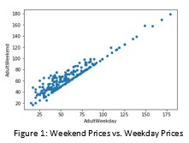The problem that Big Mountain was looking to solve was narrowed down to the following: how can Big Mountain Resort identify the dollar impact of controllable factors on ticket value, as soon as possible, in order to understand how to price tickets, maximize return on business investments, and cut costs with minimal impact on ticket revenue. All follow up actions were focused on providing a solution to this problem.

In the raw data provided by Big Mountain (330 resorts in the same market share) there were two value types for ticket price: weekend prices and weekday prices. In Montana, the two price types had identical data. Among all resorts, there was a clear line where the two price types were equal (Figure 1). Also, weekend prices had more complete data. Therefore, weekend prices were selected as the target feature for modeling.

When doing an initial exploration of the data grouped by state, it was difficult to find a consistent pattern across the features. This held true even when adjusting for resort density (resorts per capita and resorts per land area). This analysis helped support the decision to treat all states equally.

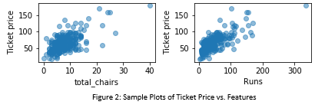Exploratory analysis also identified fast quads, runs, vertical drop, snow making, and total chairs as potentially important features. This was worth keeping in mind during the later stages of the project. Sample plots can be seen in   
Figure 2.

When beginning to build the model, the average ticket price among all resorts was used as the baseline model. Any model that did not make better predictions than the baseline was not worth considering. With this in mind, two models (a Linear Regression model and a Random Forest model) were trained and tested. Both models outperformed the baseline model.

Before making a selection between the two models, it should be noted that there was significant overlap between the features that each model found important. The linear model identified the following features from most to least important: vertical drop, snow making, total chairs, fast quads, runs, longest run, trams, and skiable terrain. The random forest model identified the following features from most to least important: fast quads, runs, snow making, and vertical drop. These features also overlap with the features that were deemed potentially important during the exploratory data analysis phase. This consensus was a good indicator that the analysis and modeling were honing in on important features for ticket price prediction.

The random forest model made better predictions than the linear model (based on mean absolute error) and showed more consistency (based on standard deviation). Therefore, the random forest model was selected.

Modeling business scenarios was the next step. First, the ticket price based on Big Mountain’s current facilities was modeled. Next, four scenarios suggested by Big Mountain executives were modeled.

Based on modeling, Big Mountain could charge $94.22 per ticket with their current facilities. However, the mean absolute error was $10.39. Accounting for the error, a conservative interpretation would be that Big Mountain could charge $83.83 per ticket (an increase over their current price of $81 per ticket). One approach could be to initially charge $83.83 but gradually increase the price to eventually reach $94.22. This would allow Big Mountain to assess the impact of each price increase on ticket sales but eventually maximize their ticket price.

Of the scenarios suggested by Big Mountain executives, the model found two of them to be potentially profitable: permanently closing up to ten runs (scenario 1) and increasing the vertical drop by 150 feet with a new run, which would require a new chairlift (scenario 2).

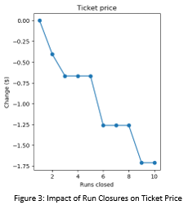For scenario 1, a single run can be closed without any impact on ticket price (Figure 3) while allowing Big Mountain to save on costs. Closing multiple runs may also be worth considering. A cost/benefit analysis would have to be done to weigh the lost ticket revenue against the reduced costs resulting from run closures. Also, there are areas where the ticket price plateaus. For example, according to the model, closing 3, 4, or 5 runs will have an identical impact on ticket price (Figure 3). This means that if Big Mountain is willing to take the loss in ticket revenue (roughly $0.70/ticket) for 3 runs, they might as well close 5 runs to benefit from reduced costs. If the business chooses to implement this strategy, one approach they could take is closing the runs gradually. This would allow them to minimize the risk of unpredicted loss in ticket revenue associated with closing runs. They could then assess the actual performance of closing one run (or a small number of runs) against the model’s prediction. If the model’s predictions appear valuable, Big Mountain could then proceed with more run closures.

For scenario 2, modeling suggests that ticket prices could be increased by $1.99. With an estimated 350,000 visitors, and an average visit of 5 days, ticket revenue would increase by $3,482,500. However, this scenario requires a new chairlift to be built. The chairlift operating costs would therefore need to be less than $1.99 per ticket sold, or $3,482,500 overall, for the scenario to be profitable (assuming that the visitors and average visit estimates are correct). Therefore, scenario 2 is worth considering but requires a cost/benefit analysis that takes chairlift costs into account.

A GUI will be designed for the Big Mountain team. This will allow them to model different feature/value combinations, using the random forest model, on their own in the future.

There were limitations in this work. The modeling accounted for ticket revenue, but not profits, because cost data was not provided. It is also possible that more fine-grained data about customer visits, or customer review/survey data would have allowed a better predictive model to be built. If this data can be collected, Big Mountain may want to revisit these areas in the future.